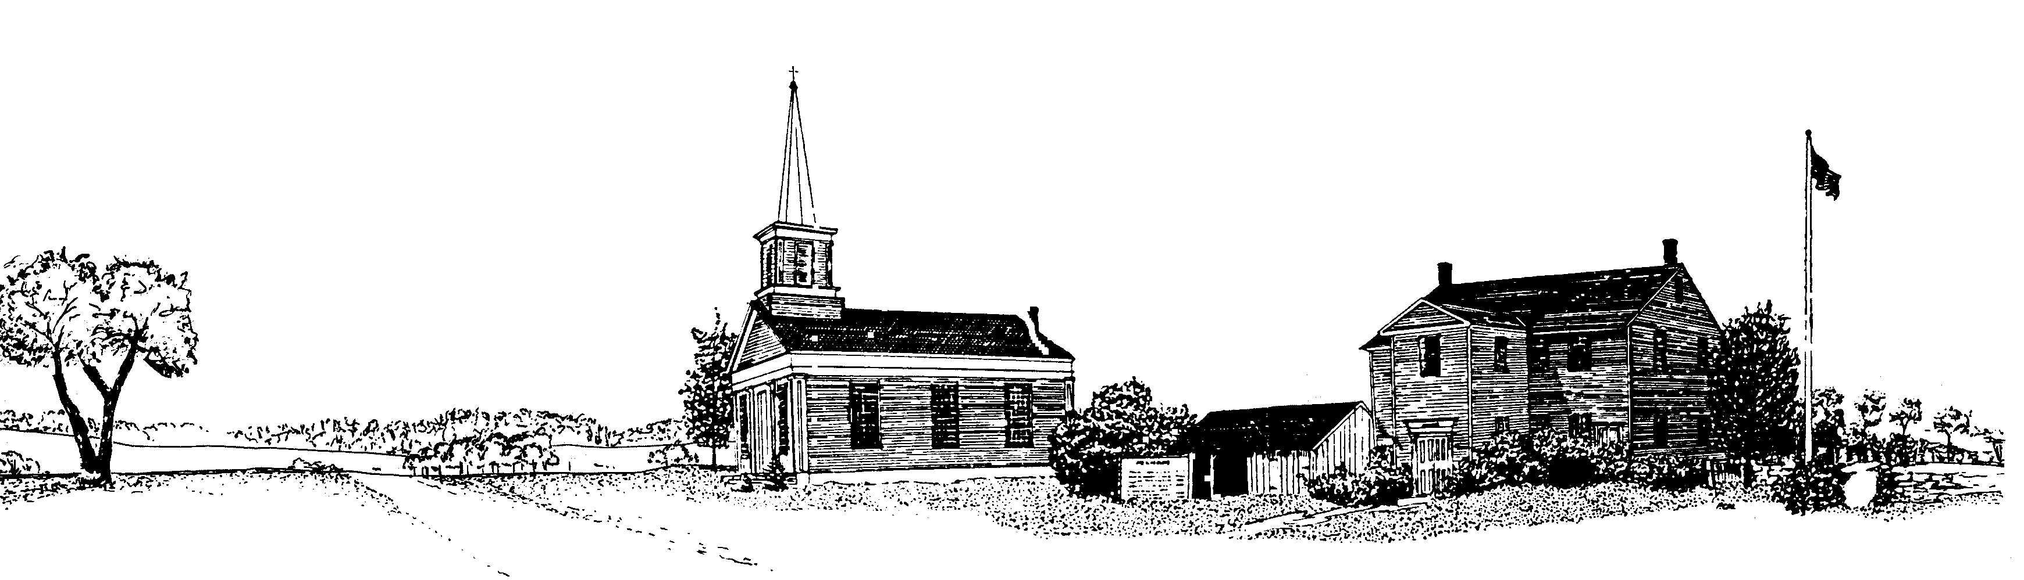TOWN OF PELHAM
HIGHWAY DEPARTMENT
351 Amherst Road, Pelham, MA 01002
phone: (413) 253-5245 email: pelhamsuper@yahoo.com
HIGHWAY DEPARTMENT FOREMAN/MECHANIC JOB DESCRIPTION
JOB SUMMARY
The Highway Foreman/Mechanic performs manual labor, operates and maintains Highway Department equipment, and maintenance of town roads. Oversees department in the absence of the Highway Superintendent. This is a full-time benefited position.

SUPERVISION
Works under the direct supervision of the Highway Superintendent. Acts in supervisory capacity during the absence of the Highway Superintendent.

MAJOR DUTIES
The essential duties and responsibilities listed include the minimum requirements for the position. The position also includes other duties as discussed in the Additional Duties section below.
Plows, sands, and patches town roads. Performs routine tree work such as clearing brush and tree removal. Mixes and pours cement. Replaces posts and signs. Removes litter and trash. Shovels snow, ice, gravel, sand, and loam. Cleans waterways, culverts, and drainage basins. Operates small equipment, tractors, tampers, and other power tools as required. Operates dump trucks with gross vehicle weight in excess of 25,000 lbs. and makes minor adjustments and services the unit as detailed in the operator’s manual. Implements a variety of maintenance tasks involving carpentry, painting, and plumbing. Operates a front-end loader and a backhoe and is able to make minor operating adjustments to service all units as detailed in the operator’s manuals.
It is required that employee operate all machinery in a safe prescribed manner.
Handles heavy materials on construction, maintenance, and repair projects. Performs preventive maintenance operations, lubricating and testing of moving parts, keeps records to permit scheduling vehicles for attention after appropriate time lapses. Must be able to work beyond a forty-hour work week, particularly during snow season and other emergencies.
During the absence of Superintendent:
Starts and completes projects. Deal with general public. Is in charge of other employees and contractors. May be required to do some daily and weekly paper work in absence of Superintendent.

ADDITIONAL DUTIES
The position includes additional duties that are a natural progression from that position’s essential duties. The omission of specific statements of duties does not exclude them from the responsibility of the employee in the position if the work is similar, related, or a logical assignment to the position.

WORK ENVIRONMENT
Most work is performed under field conditions, with exposure to extreme weather conditions, loud noise, confined spaces, hazardous elements, and traffic. The volume of work is relatively stable, but is subject to seasonal and weather fluctuations. The employee is required to respond to weather-related and other emergencies. Some repairs and maintenance work are performed under shop conditions. Schedule may include work beyond a 40-hour week, including evening, night, early morning hours, and holidays during snow season and other emergencies.
The employee operates standard office equipment, hand tools, power and pneumatic tools, various light and heavy equipment, trucks and automobiles.

MINIMUM QUALIFICATIONS
High school diploma or graduate equivalent degree. Three years of construction, snow plowing and maintenance experience.
Current and valid Massachusetts Class B driver’s license (CDL) with air brake endorsement.
Massachusetts Hydraulic Operators license (Hoisting) to operate a front-end loader and backhoe. Ability to understand and follow directions, working knowledge of tools, equipment, and procedures used in automotive and equipment repair work, and the ability to perform equipment repair and maintenance.
Some knowledge of the geography of the community.
Demonstrated mechanical repair ability including welding, common knowledge of hydraulic and engine repair and maintenance with the ability to acquire required equipment certifications.
PHYSICAL REQUIREMENTS
Moderate to strenuous physical effort is generally required to perform work in the field, with exposure to varied weather conditions. The employee is routinely required to site, stand, walk, reach, stoop, climb, and operate vehicles and heavy equipment. The employee is frequently required to lift, move, and/or push items weighing over 50 lbs. Vision requirements include the ability to read and understand routine and complex documents and operate motor vehicles and other equipment.

A pre-employment physical shall be required.

SALARY
Salary is based on experience.

AFFIRMATIVE ACTION
The Town of Pelham is an Equal Employment Opportunity (EEO) and Affirmative Action (AA) Employer.

Letter of interest, resume, and references to Highway Superintendent, Town of Pelham, 351 Amherst Road, Pelham, MA, 01002.

Position will be open until filled.

