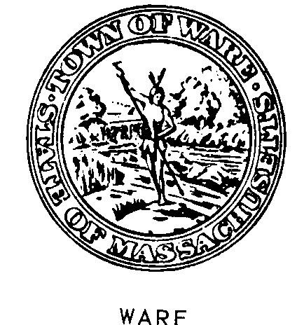
Office of
QUABBIN HEALTH DISTRICT
126 Main Street Ware, Massachusetts 01082

COVID-19 Cases and Deaths as of Saturday, December 26, 2020
Sunday December 20, 2020 to Saturday December 26, 2020
Belchertown
Total Cases to date | 356
Confirmed PCR New Cases this Week (Sun- Sat 12/26/20) | 31
COVID -19 Deaths to date | 12
New COVID Deaths this reporting period | 0
Number of tests on Belchertown residents as of 12/24/20 | 17805
Test performed this weekly period | 958
Ware
Total Cases to date | 194
Confirmed PCR New Cases this Week (Sun- Sat 12/26/20) | 24
COVID -19 Deaths to date | 5
New Covid Deaths this reporting period | 0
Number of tests on Ware residents as of 12/24/20 | 8967
Test performed this weekly period | 510
Pelham
Total Cases to Date (1 transferred to another community) | 18
New Cases this Week (Sunday- Saturday 12/26/20) | 2
COVID -19 Deaths to date | 0
Number of tests on Pelham residents as of 12/24//20 | 726
Test performed this weekly period | 49

